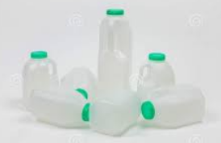
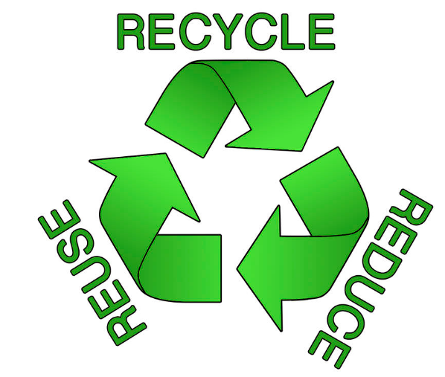
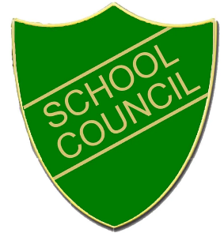
- When on the playground, always put your empty plastic milk bottle in the recycling bin.
- If you drink milk in your classroom, use a box to collect the empty plastic bottles.
- Make it a classroom job for someone to take them to the recycling bin.
- Put plastic bottles from your packed lunches in the recycling bin.
At Fairlands Primary School
We Reduce, Reuse and Recycle.

