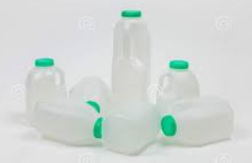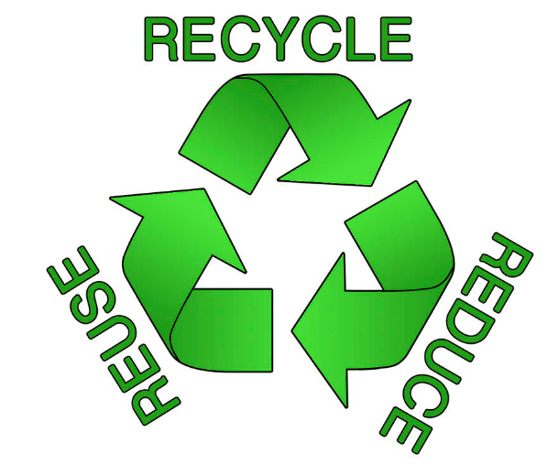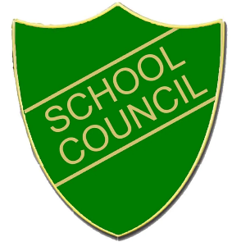

* When on the playground, always put your empty plastic milk bottle in the recycling bin.
* If you drink milk in your classroom, use a box to collect the empty plastic bottles.
* Make it a classroom job for someone to take them to the recycling bin.
* Put plastic bottles from your packed lunches in the recycling bin.

***At Fairlands Primary School***

***We Reduce, Reuse and Recycle.***