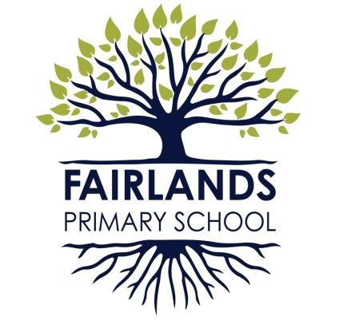
FAIRLANDS PRIMARY SCHOOL

Pound Avenue

Stevenage

Hertfordshire

SG1 3JA

Headteacher: Mr Robert Staples BA (Hons)

Tel: (01438) 351053 Fax: (01438) 750116 E-mail: admin@fairlands.herts.sch.uk Web: www.fairlands.herts.sch.uk

The Great Fire of
London
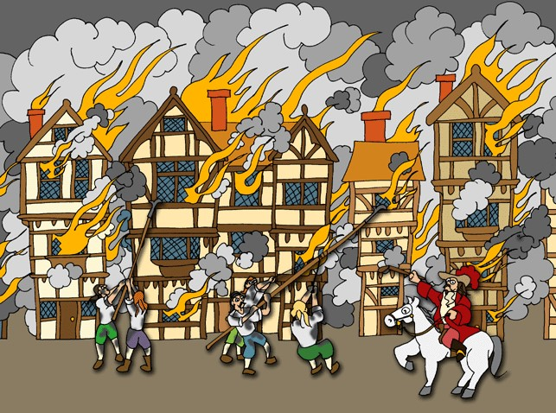

Year 2 Spring Term 1 2023
Curriculum focus for this topic are:
History – British History
Maths – Statistics & Time
English – Whole school writing project based on the story ‘The Midnight Fair’
Art- Observational Drawing
Science – Materials & Working Scientifically
Design & Technology – Joining materials
New Technologies – Starting Research
Music – Creating & developing musical ideas
PE – Dance

