TT Rockstars Competition!
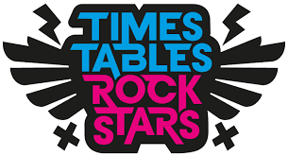
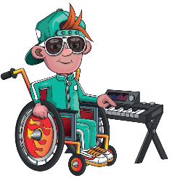
Friday 27th January 2023 will be our TT Rockstars Day here at Fairlands! You will be taking part in some times tables activities and you will be able to dress up like your very own rockstar!
Before this day, we would like you to create a times tables project and bring it in by Wednesday 25th January. These can be displayed all around school to help us all remember our timestables.
We will be picking one child’s project for each year group whose work shows that they have put effort and imagination into their project. Winners will be announced in Achievement Assembly on TT Rockstars Day. These children will receive a prize and will even have their homework posted on the blog for the whole school to see!
Here are some ideas for what you could do:

