Friday 5th May 2023
All homework sheets can be found on the school blog via the Fairlands school website
Blog - Fairlands Primary School & Nursery – Year 2
Key Dates:
Bank holiday, Monday 8th of May.
Reading
It is important that your child continues to practise their reading at home. Please remember to read at home at least three times a week. This can be the Little Wandle e-book, the free reader book, library book (from school and the public library), recipes, magazines etc.

Principles:
This month’s value is ‘love’. We will be spending time talking about what love means and how we can show this. Please talk to your child about times when they have felt loved or have loved someone or something, Also what does love mean to them and how can they demonstrate that in the future.

Reminders
Elm will have PE on Mondays, Elder class on Tuesdays and Fir class on Thursdays. Please ensure your child has full kit (including outdoor shoes) in school from the first day back Also please remember that your child should only have water in their water bottle, not juice. Children should not be wearing hoops. Children wearing any earrings other than small, simple studs will be asked to remove or cover them.
Please remember that children should not be bringing in any toys etc from home as this can cause arguments between the children and upset the children if they lose things.

Spellings: Please ask your child to practise the spellings from the group they feel most comfortable with, as they do with their learn its.
Spelling strategies
- Write the spellings in a sentence
- Use rainbow writing
- Write the word in a pyramid
- Use magnetic letters
- Write it in flour, shaving foam etc

Apprentice | Practitioner | Expert
are  her  was | home  bone  game  blame  time  crime | you’re  softly  bottle  shyly  sweetly  don’t
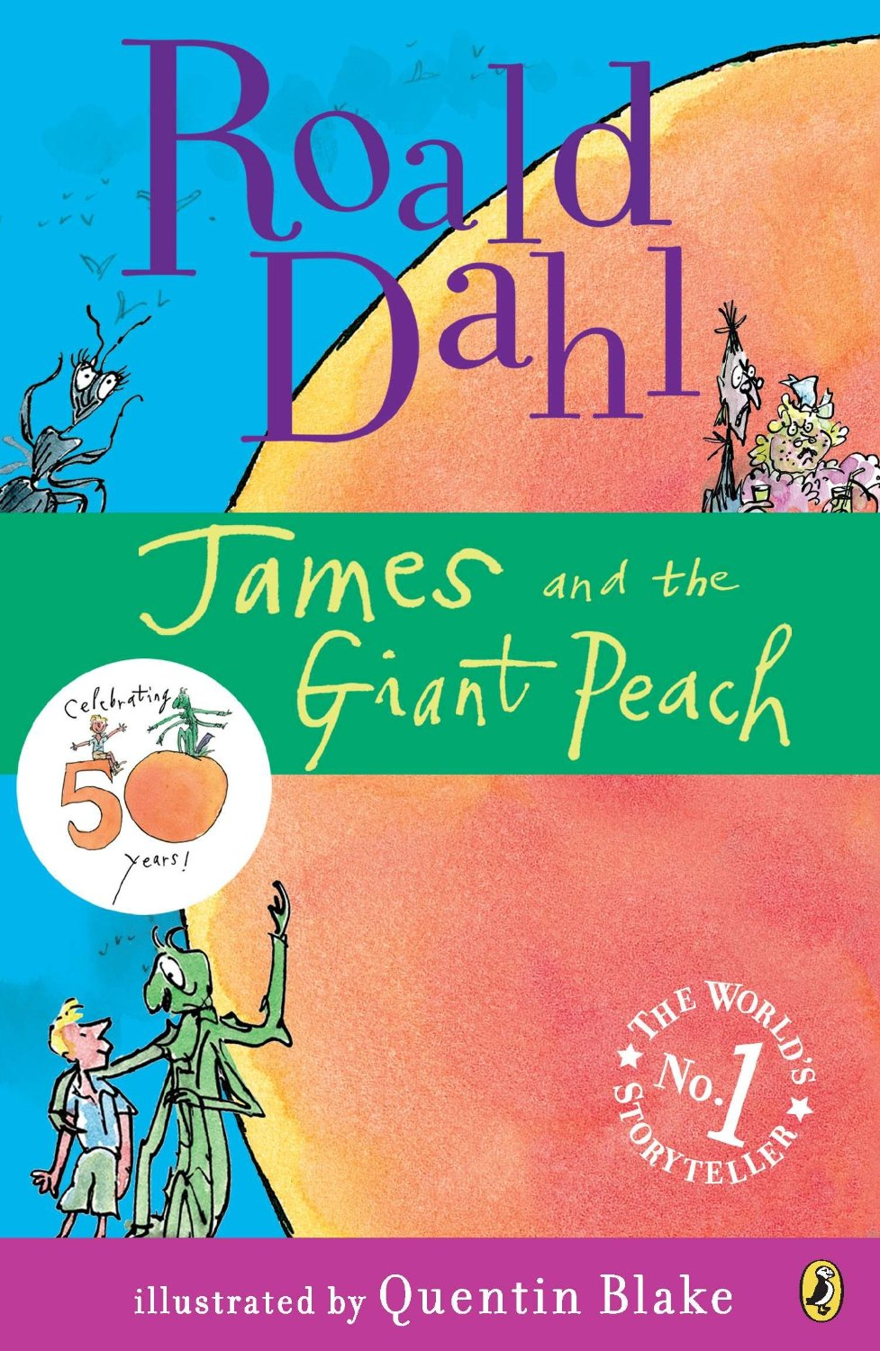
Learnt its
Apprentice: Practice counting in 3s up to 30. Can you challenge your child to count backwards?
Practitioner: Practice your 4 times table!
You need to know these as quick as a flash!
Expert: Challenge yourself with facts from the 4 times table. Do you know the switcher?

Homework Activity
We have begun reading our core text for this half term, ‘James and the Giant Peach’. This half term we would like you to design your own front cover for a story starring you and a giant fruit or vegetable. For example Mrs Abdul and the Giant Tomato, Mr Barnett and the Giant Broadbean or Mrs Harnett and the Giant Potato. Be as artistic as you can when creating your front cover. Please bring in your homework project by the 12th May.
Mrs Abdul, Mrs Marlow, Mrs Harnett and Mr Barnett

