Schools Competition May 2023
Stevenage Borough Council, in partnership with Polly Owen, local Hertfordshire author, invite you to take part in a competition to win a signed copy of Darwin's Super-Pooping Worm Spectacular book and a wormery to turn your GREEN WASTE into BLACK GOLD!
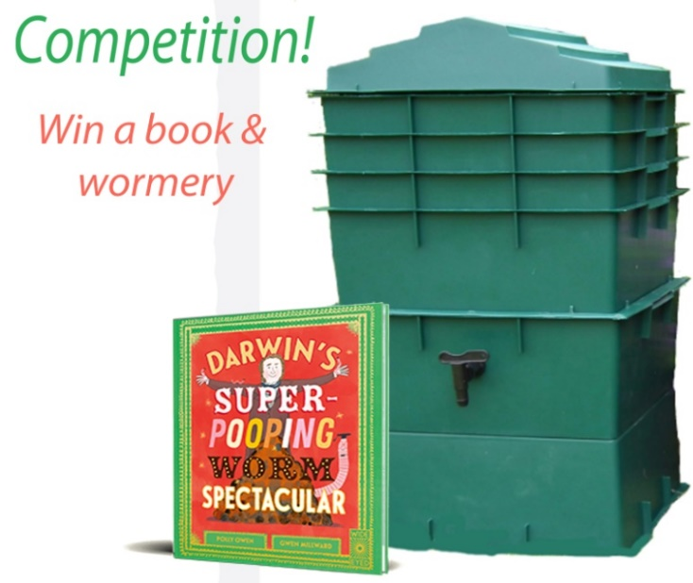
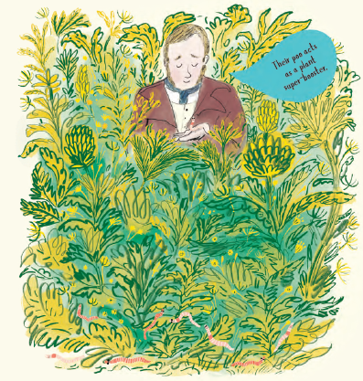

Who can take part?
All nursery, infant and primary schools or academies in Stevenage are invited to take part. It would be particularly beneficial to any school that has an eco-council, eco-club, gardening club or similar.
For a chance to win a signed and dedicated copy of Darwin’s Super-Pooping Worm Spectacular and a wormery worth £95, we are asking children to complete our poster on the next page with pictures of items that can be composted.

Hint - This could include the following: Leaves, flowers, grass cuttings, vegetable peelings, tea bags, fruit (inc. apple cores, banana skin, orange peel)

The winning design will be used on Stevenage BC’s social media to help promote messages around home composting. The winner will also be contacted via their school to be invited to have their photo taken with their winning design.

Competition Page

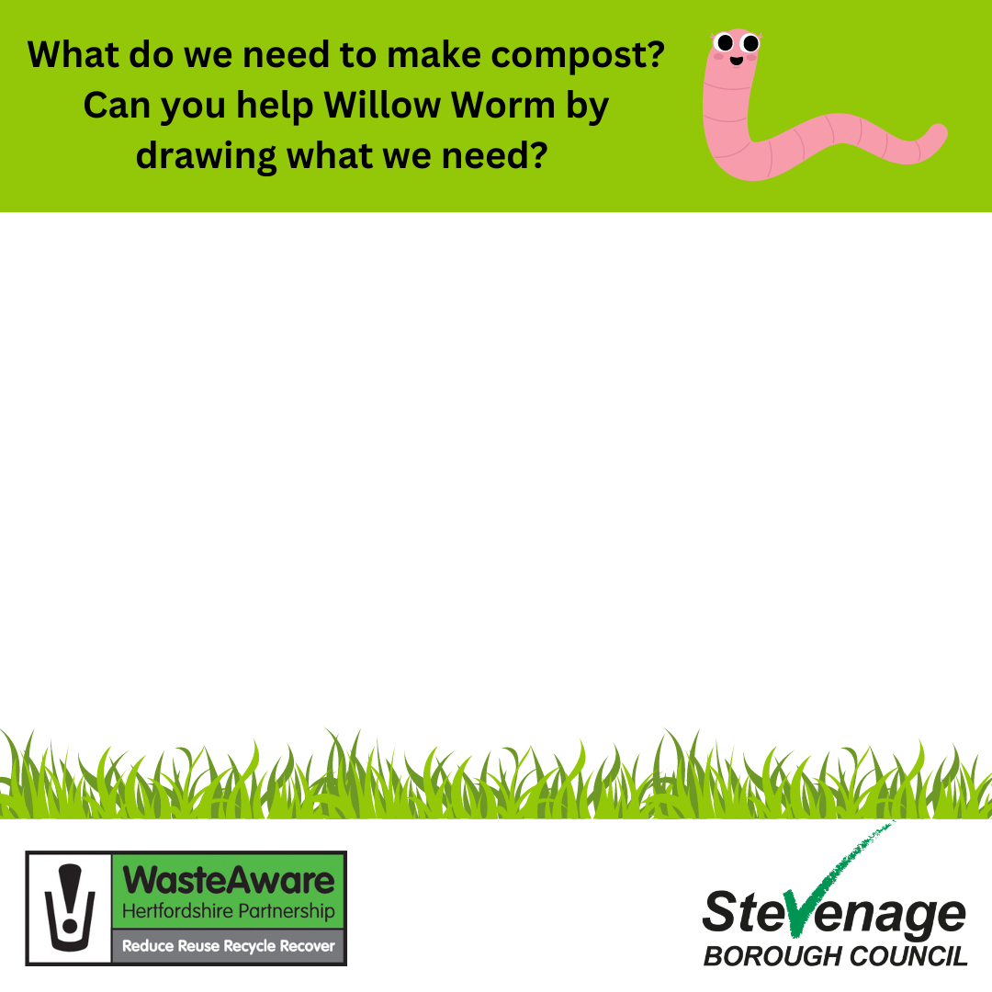

Completed by (first name):
Age:
School:

Composting your food waste
Composting your food waste creates a rich, nutritious fertiliser for your plants. Instead of buying expensive bags of compost, a wormery will keep well supplied for free. Once your system is up and running it's quick and easy to maintain and takes care of all your food and garden waste.
Why a wormery?
Earthworms produce 1 inch of soil every 5 years. They compost all organic material and create a super-boosting plant fertiliser. Charles Darwin discovered the power of earthworms' poo when he studied them 150 years ago and declared them to be one of the most important creatures on the planet. The story of Darwin's earthworm experiments is told for the first time for children, in Polly Owen's new picture book: Darwin's Super-Pooping Worm Spectacular (Yes, he really did play them the bassoon!)

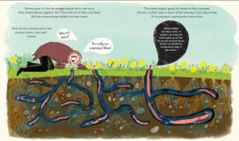

But I have too much waste!
Food waste soon decomposes into small amounts of soil. As long as you layer your food waste with twigs and leaves to make sure it's not too acidic, worms can eat up to their own weight in food per day! Darwin discovered earthworms’ favourite leaves were cherry and celery, but don't worry, they'll eat anything!
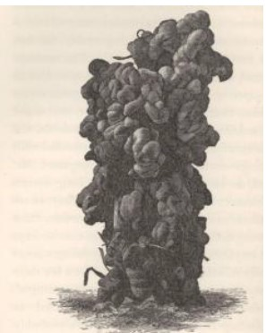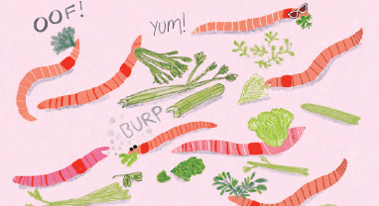
But I've not used a wormery before
The wormery comes with simple instructions to have you up and running in no time. There are also plenty of YouTube videos that can help.

About the Author

Polly Owen is a local author from Hertfordshire. She wrote Darwin's Super-Pooping Worm Spectacular after her daughter showed an interest in worms a picture book for a new audience. To buy a copy of this book visit: https://www.amazon.co.uk/Darwins-Super-Pooping-Worm-Spectacular-Polly/dp/0711275955

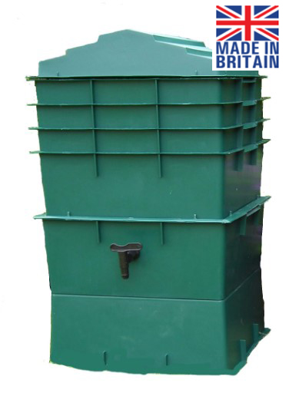
The Wormcity Wormery has been specially designed to take advantage of a worm’s lifestyle. It contains a series of composting trays, with holes in the base. Start the worms in the bottom tray and add your kitchen waste. When it's full, add a tray on top and start filling it up. Repeat with other trays.
The worms will eat the kitchen waste on the bottom level, and because they are surface dwellers, will move upwards, leaving behind vermicompost (worm poo) which you can use on your garden.
When they reach the top tray, the lowest tray should be completely composted and can be used in the garden. Put the empty tray on top.
It only takes a few minutes each week!

Winner of Gardener's World Best Buy Wormery
Colour may vary. Available in green and black.

More information on composting is available on the Recycle Now website or the Hertfordshire WasteAware Partnership website.
And for more information on earthworms, visit the Earthworm Society: https://www.earthwormsoc.org.uk

How to Enter
To be in with a chance of winning, you can email your entry to claire.nicholls@stevenage.gov.uk or alternatively, post or deliver to Stevenage Borough Council, Cavendish Road, Stevenage, SG1 2ET for attention of Claire Nicholls.
Competition closes: 26th May 2023

