Friday 12th May 2023
All homework sheets can be found on the school blog via the Fairlands school website
Blog - Fairlands Primary School & Nursery – Year 2
Key Dates:
Last day of school, Friday 26th of May.
Resources
Next term our topic is Australia and for our D & T project we will be making digeridoos and would appreciate if you can collect cardboard tubes, e.g. kitchen roll, Pringles tubes or wrapping paper tube. We will also be making boomerangs and need cereal boxes. Please bring them in by the 7th of July. Thank you!

Reading
It is important that your child continues to practise their reading at home. Please remember to read at home at least three times a week. This can be the Little Wandle e-book, the free reader book, library book (from school and the public library), recipes, magazines etc.

Principles:
This month’s value is ‘love’. We will be spending time talking about what love means and how we can show this. Please talk to your child about times when they have felt loved or have loved someone or something, Also what does love mean to them and how can they demonstrate that in the future.

Reminders
Elm will have PE on Mondays, Elder class on Tuesdays and Fir class on Thursdays. Please ensure your child has full kit (including outdoor shoes) in school from the first day back Also please remember that your child should only have water in their water bottle, not juice. Children should not be wearing hoops. Children wearing any earrings other than small, simple studs will be asked to remove or cover them.
Please remember that children should not be bringing in any toys etc from home as this can cause arguments between the children and upset the children if they lose things.

Spellings: Please ask your child to practise the spellings from the group they feel most comfortable with, as they do with their learn its.
Spelling strategies
- Write the spellings in a sentence
- Use rainbow writing
- Write the word in a pyramid
- Use magnetic letters
- Write it in flour, shaving foam etc

Apprentice | Practitioner | Expert
said  have  like | didn’t  singing  tester  dullest  washed  You’re | baldness  helpfulness  painless  apple  little  won’t
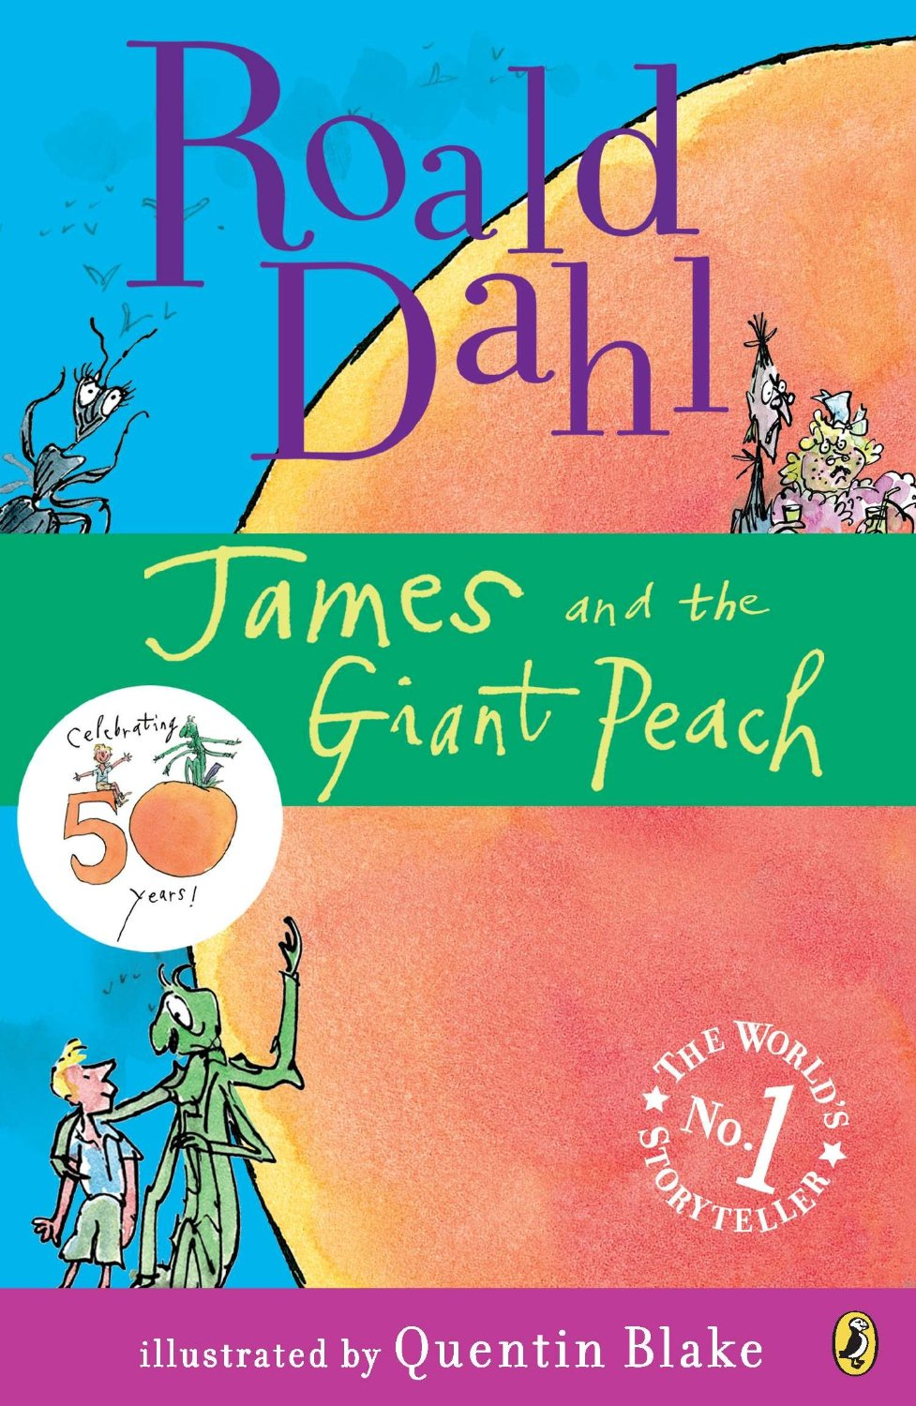
Last week we learnt about 2D and 3D shapes:
Apprentice: Draw a square, circle and a triangle and write how many sides and corners they have.
Practitioner: Draw a cube, cuboid, cylinder. How many edges, vertices and faces they have?
Expert: Draw a cube, cuboid, square-based pyramid, and cylinder. How many edges, vertices and faces they have?

Homework Activity
Homework for the next 3 weeks, we would like you to try and grow some plants or flowers at home. You could try planting some seeds in a pot or in your garden. Remember to give your seeds some water and put them somewhere sunny. Cress seed grow quite quickly or you could try planting some flowers or maybe you have an allotment that you can go and observe with your grown-ups. Please bring in a picture or a drawing of what your plant looks like by the 8th of June.
Mrs Abdul, Mrs Marlow, Mrs Harnett and Mr Barnett

