Friday 22th September 2023
All homework sheets can be found on the school blog via the Fairlands school website

Reminders
We are very lucky to have Safari Stu visiting us on Tuesday 26th September. He will be bringing in a variety of animals for the children to experience. This is a great opportunity for the children to see and hold animals that they have never seen before and we are all very excited! If you haven’t already, you can make the payment for this through Arbor.

Topic
This term our topic is Amazing Animals. Each half term we have a project linked to our topic. This half term, we would like the children to research their favourite animal. When they have researched an animal and found out some fun facts, we would like them to display their findings in a way of their choosing. This could be a poster, a model, a fact file or even a PowerPoint. We would love to have them in by Friday 13th October so they can share them with the rest of the class.

Reading
Pupils will now have taken home their reading record and reading book. These books are aligned to our Little Wandle phonics scheme. Please remember to read at home at least three times a week and write in your child’s reading record when you have read.
Reading books will be changed each week if your child has read at home.

Values
This month’s value is ‘responsibility’. We have been looking at ways the children can be responsible in school. For example, by looking after school resources, tidying up after themselves and making sure they look after their own belongings. Please help your child to do this by making sure each item of clothing is clearly labelled with their name.

Phonics;
We have been recapping the following sounds in phonics this week;
Sh, ch, th, ng, ck, ai, ee, igh, oa, oo, ow, or, ear, air, oi, ar, ur and er.
Next week we will be starting to learn Phase 5 digraphs.
See if your child can spot the graphemes in the following words;

thing farmyard chicken lightning smear fair clown point train fort

Learn its Pupils should choose their challenge and complete the maths questions. If pupils bring their answered questions into school, they can move up the learning ladder!
Apprentice: 1 more than 3 is ... 1 more than 6 is ... 1 less than 5 is ... 1 less than 2 is ...
Practitioner: 1 more than 9 is ... 1 more than 13 is ... 1 less than 9 is ... 1 fewer than 15 is ...
Expert: 1 more than 19 is ... 1 more than 29 is ... 1 less than 13 is ... 1 fewer than 20 is ...
Challenge: 6 is one more than ... 9 is one less than ...

Kindness workshop
This week, we had a workshop all about Kindness with the charity ‘52 lives’. We discussed how we can show kindness to each other and ourselves. Can you practise speaking kindly to yourself at home using the sheet on the following page to help you?

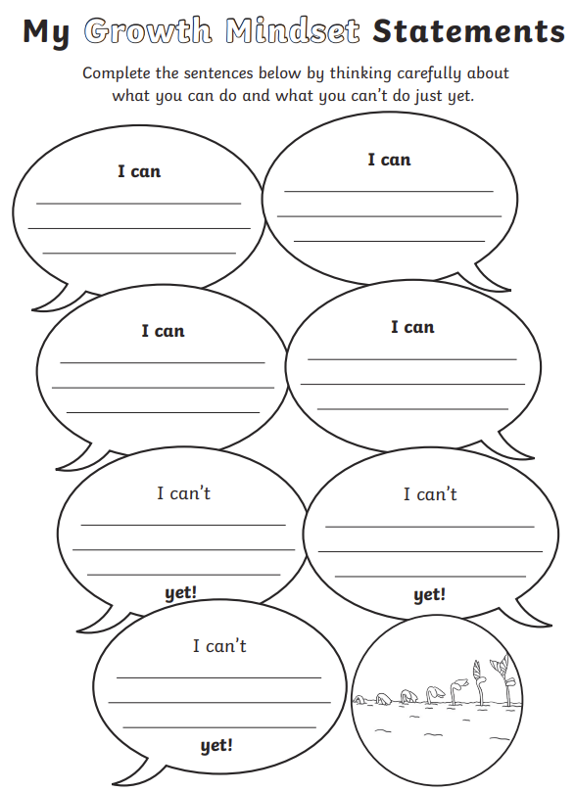
Mr Barnett, Mrs Wrangles, Mrs Quilter

